**BENADIR UNIVERSITY**

**DECLARATION OF THESIS / UNDERGRADUATE PROJECT**

Title: **DENTAL CLINIC MANAGEMENT SYSTEM/MOBILE APP**

Academic Session: 2022/2023

Names of group project:

1. **Abdi Abdirizak Omar**
2. **Sayid Amin Mohamd**
3. **Kamal Abdirahman Yusuf**
4. **Abdirahman Ali Hassan**



**SIGNATURE OF SUPERVISOR(s) SIGNATURE OF DEAN**

…………………………….. …………………………….

……………………………..

Date: 22 Aug 2023

**NAME OF DEAN**

**NAME OF SUPERVISOR(s)**

“I hereby declare that I have read this Project and in my

opinion this Project is sufficient in terms of scope and quality for the

Signature :

Name of Supervisor : ENG. …………………..

Date : MAY 2023

DENTAL CLINC MANAGEMENT SYSTEM/MOBILE APP

1. ABDI ABDIRIZAK OMAR

2. SAYID AMIN MOHAMED

3. KAMAL ABDIRAHMAN YUSUF

4. ABDIRAHMAN ALI HASAN

A Project submitted in partial fulfillment of the

requirements for the award of the Bachelor degree of

Computer Science and Information Technology

Faculty of Computer Science and Information Technology

Benadir University

AUGUST 2023

We declare that this Project entitled “*Dental clinic Management system/Mobile App*” is the result of Our own research except as cited in the references. The Project has not been accepted for any degree and is not concurrently submitted in candidature of any other degree.

Signature: ....................................................

Name : Abdi Abdirizak Omar

Signature : ....................................................

Name : Sayid Amin Mohamed

Signature : ....................................................

Name : Kamal Abdirahman Yusuf

Signature : ....................................................

Name : Abdirahman Ali Hassan

Date : Aug 22, 2023

This Project is dedicated to Our family for their endless support and encouragement.

**ACKNOWLEDGEMENT**

First and foremost, we would like to express heartfelt gratitude to Our supervisor **Eng. Mohamed Abdulkadir Hajji** for his constant support during my study at BU. He inspired Us greatly to work in this project. His willingness to motivate us contributed tremendously to our project. We have learned a lot from him and We Are fortunate to have him as Our mentor and supervisor

Additionally, we would like to thank the authority of Benadir University (BU) for providing Us with a good environment and facilities such as Computer lab to complete this project with software which We need during process.

**ABSTRACT**

The efficient management of dental clinics is crucial for providing quality dental care and ensuring a seamless patient experience. This Book presents a comprehensive dental clinic management system integrated with a user-friendly dental appointment mobile application. The management system is designed to handle daily administrative tasks, while the mobile app allows customers to conveniently book appointments.

The dental clinic management system serves as a centralized platform for the streamlined organization of various aspects of clinic operations. It encompasses features such as patient registration, appointment scheduling, staff management, inventory control, and billing. With an intuitive user interface, it enables dental professionals to efficiently manage patient records, track treatment histories, and schedule appointments, thereby optimizing workflow and minimizing administrative overhead.

Complementing the management system, the dental appointment mobile app, caters to the evolving needs of patients by providing a user-friendly interface accessible from smartphones and tablets

**TABLE OF CONTENTS**

|  |  |  |  |  |  |  |  |
| --- | --- | --- | --- | --- | --- | --- | --- |
| **CHAPTER** | | | | **TITLE** | | | **PAGE** |
|  | | | |  | | |  |
|  | | **DECLARATION** | | | | | iii |
|  | | **DEDICATION** | | | | | iv |
|  | | **ACKNOWLEDGMENT** | | | | | v |
|  | | **ABSTRACT** | | | | | vi |
|  | | **TABLE OF CONTENTS** | | | | | vii |
|  | | **LIST OF TABLES** | | | | | x |
|  | | **LIST OF FIGURES** | | | | | xi |
|  |  | | | | | |  |
| **1** | **INTRODUCTION** | | | | | | 12 |
| 1.0 | | Introduction | | | | 12 |
| 1.1 | | Problem Background | | | | 13 |
| 1.2 | | Problem Statement | | | | 14 |
| 1.3 | | Objectives of DCMS | | | | 15 |
| 1.4 | | Project Scope | | | | 15 |
| 1.5 | | The Project Importance | | | | 16 |
| 1.6 | | Summary | | | | 17 |
|  |  | | | | | |  |
| **2** | **LITERATURE REVIEW** | | | | | | 18 |
| 2.0 | | Introduction | | | | 18 |
| 2.1 | | History of Dental Clinics and DCMSs | | | | 19 |
| 2.2 | | Features of Effective DCMS | | | | 21 |
| 2.2.1 | | Patient management | | 21 |
| 2.2.2 | | Electronic Health Record | | 21 |
| 2.2.3 | | Treatment Planning | | 22 |
| 2.2.4 | | Billing and Payment | | 22 |
| 2.2.5 | | Inventory Management | | 22 |
| 2.2.6 | | Usability | | 22 |
|  | |  | |  |
| 2.3 | | Benefits of DCMS | | | | 22 |
| 2.3.1 | | Improved Efficiency | | 22 |
| 2.3.2 | | Enhanced Patient Care | | 23 |
| 2.3.3 | | Streamlined Operations | | 23 |
| 2.3.4 | | Cost Saving | | 23 |
| 2.3.5 | | Improved Compliance | | 23 |
| 2.4 | | Challenges of Implementing DCMSs | | | | 23 |
| 2.4.1 | | Cost | | 23 |
| 2.4.2 | | Integration | | 24 |
| 2.4.3 | | Technical Issues | | 24 |
| 2.4.4 | | Security | | 24 |
| 2.4.5 | | Data Conversion | | 24 |
| 2.5 | | Existing Systems | | | | 24 |
| 2.5.1 | | Denticon by Planet DDS | | 24 |
| 2.5.2 | | Curve Dental | | 26 |
| 2.5.3 | | Open Dental | | 27 |
| 2.5.4 | | Eaglesoft by Patterson Dental | | 29 |
| 2.5.5 | | Dentrix by Henry Schein One | | 30 |
| 2.6 | | Summary | | | | 32 |
|  |  | | | | | |  |
| **3** | **METHODOLOGY** | | | | | | 32 |
| 3.0 | | Introduction | | | | 32 |
| 3.1 | | Operational Framework | | | | 33 |
| 3.1.1 | | System Development Life Cycle | | 33 |
| 3.1.2 | | Iterative model | | 33 |
| 3.2 | | Work Breakdown Structure | | | | 34 |
| 3.3 | | System Requirements | | | | 36 |
| 3.3.1 | | Software Requirements | | 36 |
| 3.3.1.1 | Functional Requirements | 37 |
| 3.3.1.2 | Non-Functional Requirements | 37 |
| 3.3.1.3 | Domain Requirements | 37 |
| 3.3.2 | | User Requirements | | 38 |
| 3.4 | | Problem Analysis Identification | | | | 38 |
| 3.5 | | Requirement Gathering Techniques | | | | 38 |
| 3.5.1 | | Interview | | 38 |
| 3.5.2 | | Observation | | 39 |
| 3.6 | | Process Modeling | | | | 39 |
| 3.6.1 | | Data Flow Diagrams | | 39 |
| 3.6.2 | | Unified Modeling Language (UML) | | 39 |
| 3.6.2.1 | Use Case Diagram (UCD) | 40 |
| 3.7 | | Data Modeling | | | | 41 |
| 3.7.1 | | Entity Relationship Diagram (ERD) | | 41 |
| 3.7.1.1 | Entity Relationship Diagram (ERD) Symbols | 41 |
| 3.7.1.1 | Types of Relationships | 42 |
| 3.8 | | System Feasibility | | | | 43 |
| 3.8.1 | | Technical Feasibility | | 43 |
| 3.8.2 | | Operational Feasibility | | 44 |
| 3.8.3 | | Schedule Feasibility | | 45 |
| 3.9 | | Summary | | | | 45 |
|  | |  | | | |  |
| **4** | **SYSTEM DESIGN** | | | | | | 45 |
| 4.1 | | Introduction | | | | 46 |
| 4.2 | | Architectural Design | | | | 46 |
| 4.3 | | User Interface | | | | 46 |
| 4.3.1 | | Web Interface | | 46 |
| 4.3.2 | | Mobile Interface | | 48 |
| 4.4 | | Database Storage Design | | | | 51 |
| 4.5 | | Database Design | | | | 52 |
| 3.5.1 | | Database Normalization  3.5.1.1 First Normalization Form  3.5.1.2 Second Normalization Form  3.5.1.3 Third Normalization Form | | 53  54  55  56 |
| 4.5.2 | | Converting ER Diagrams into Relational Representations | | 57 |
| 4.6 | | Summary | | | | 57 |
|  |  | | | | | |  |
| **5** | **SYSTEM IMPLEMENTATION** | | | | | | 58 |
| 5.1 | | Introduction | | | | 58 |
| 5.2 | | Coding Phase | | | | 58 |
| 5.2.1 | | Splash Code | | 59 |
| 5.3 | | User Interface Development | | | | 60 |
| 5.4 | | Interface Menu Options | | | | 61 |
| 5.5 | | The process of Appointment | | | | 61 |
| 5.6 | | Handling The Appointment from The Web | | | | 61 |
| 5.7 | | Summary  **Conclusion**  **Recommendations For Future Works**  **References**  **Appendices**  **Appendices A**  **Appendices B** | | | | 62  62  62  63  65  65  66 |

**LIST OF TABLES**

|  |  |  |
| --- | --- | --- |
| TABLE | TITLE | PAGE |
| 3.1 | Technical Feasibility | 44 |
| 3.2  4.1  4.2  4.3 | Operational Feasibility  Employee before Normalization  First Normal Form(1NF)  Second Normal Form(2NF) | 44  54  55  56 |

**LIST OF FIGURES**

|  |  |  |
| --- | --- | --- |
| FIGURE | TITLE | PAGE |
| 2.1 | A microscopic device used in dental analysis, c. 1907 | 19 |
| 2.2 | Modern Dentist Chair | 21 |
| 2.3 | Denticon Patient Chart with Integrated Imaging | 25 |
| 2.4 | Curve hero Charting | 26 |
| 2.5 | Appointment Module – Open Dental | 28 |
| 2.6 | EagleSoft | Chart | 29 |
| 2.7 | Dentrix Data Entry | 31 |
| 3.1 | Model of the software development life cycle | 33 |
| 3.2 | The Iterative Methodology | 34 |
| 3.3 | Types of Software Requirements | 37 |
| 3.6.2.1 | Symbols of Use Case Diagrams (UCD) | 40 |
| 3.6.2.2  4.2.1  4.2.2  4.3  4.4  5.1.1 | Example of Use Case Diagrams (UCD)   1. Web Login page 2. Appointments Interface 3. Web Interface Dashboard 4. Login Interface Mobile App 5. Home Page Interface Mobile App 6. Appointments Interface Mobile App   Database Tables and Views  Database Design  Splash Code in Flutter-Mobile App | 40  47  47  48  49  50  51  52  53  60 |

**INTRODUCTION**

## Introduction

Dentistry, according to the World Health Organization, is the field of knowledge and skill that deals with preventing, detecting, and curing disorders, injuries, and abnormalities of the teeth, jawbones, and oral cavity. Dentists are responsible for diagnosing and fixing issues with teeth and mouth tissues, as well as providing guidance and care to help prevent any future problems. (F & F, 2008)

According to the World Health Organization (WHO), there is an acute shortage of dental professionals in Somalia, with only one dentist per 300,000 people, compared to the WHO's recommended ratio of one dentist per 7,000-10,000 people. To say this statement has aged poorly would be a massive understatement.

There has been an increase of Dental Clinics in Somalia in recent years. In one part of Madina alone, we were able to count eight different dental clinics. That’s right, Eight! And this number is not going down anytime soon. As more and more people realize the merits of oral hygiene, even more dental clinics will emerge.

More dental clinics means more challenges for the owners and practitioners. In order to improve the delivery of dental care and overcome the obstacles faced, it is essential to consider new and affordable solutions that utilize technology and data effectively. A possible solution to this problem is the implementation of a dental clinic management system (DCMS), which is a software program designed to automate and simplify different aspects of clinic management, including patient registration, appointment scheduling, record keeping, billing, and inventory management.

In the last few years, the adoption of DCMS has seen a significant increase in dental clinics due to technological advancements, cost-effectiveness, revenue generation, and the aim to enhance patient contentment and safety. Nonetheless, the deployment and application of DCMS can create certain difficulties, including employee education, assimilation with current systems, adaptation to regional requirements, and supervision of data protection and confidentiality.

## Problem Background

The importance of dental care cannot be overstated, as it is a crucial component of overall health and wellness. However, in numerous regions of the globe, people do not have access to high-quality dental services. According to the World Health Organization (WHO), oral diseases impact approximately 50% of the world's population, and if left untreated, they can cause pain, infections, and even fatalities. In low- and middle-income countries (LMICs), dental diseases are a significant burden, and individuals often struggle to find affordable or accessible dental care services.

Furthermore, the standard of dental treatment in low and middle-income countries (LMICs) is negatively impacted by the insufficient capabilities and resources of dental clinics. A lot of clinics are deficient in essential equipment and materials, including dental chairs, X-ray machines, and anesthesia, which adversely affects the provision of thorough and secure treatment. Moreover, dental clinics management in LMICs is often done manually, using paper-based systems, which results in inaccuracies and inefficiencies, such as misplaced records, overlapping appointments, and incorrect billing.

Therefore, this thesis aims to investigate the feasibility, acceptability, and impact of DCMS in dental clinics in Somalia. The study will explore the challenges and opportunities of DCMS adoption and use, the factors that influence its effectiveness and sustainability, and the outcomes on patient care, clinic efficiency, and staff satisfaction.

## Problem Statement

Although dental care plays a crucial role in maintaining general health, numerous regions across the globe, particularly those belonging to low- and middle-income countries (LMICs), face a scarcity of quality dental services. The limited facilities and resources of dental clinics operating in LMICs hinder the accessibility and quality of dental care, thereby giving rise to extended waiting periods, incomplete treatment, and a substantial prevalence of dental diseases. Additionally, the manual, paper-based management of dental clinics in LMICs increases the probability of errors and inefficiencies, which further obstruct the provision of comprehensive and secure care.

In order to tackle the difficulties faced by dental clinics in LMICs, a dental clinic management system (DCMS) has been developed as a viable solution. The implementation of DCMS has the capability to simplify clinic operations, minimize administrative duties, increase data precision and security, and elevate patient satisfaction. Nevertheless, the acceptance and utilization of DCMS in LMICs are impeded by a number of obstacles including insufficient technical know-how, financial resources, and infrastructure.

Therefore, the problem statement of this thesis is to investigate the feasibility, acceptability, and impact of DCMS in dental clinics in Madina (Mogadishu, Somalia). Specifically, the study aims to answer the following research questions:

### What are the challenges and opportunities of DCMS adoption and use in dental clinics in Somalia?

### What are the factors that influence the effectiveness and sustainability of DCMS in dental clinics in Somalia?

### What are the outcomes of DCMS implementation on patient care, clinic efficiency, and staff satisfaction in dental clinics?

By answering the research questions, valuable information can be obtained about the effectiveness of DCMS in enhancing dental care delivery and management in LMICs. This information can be used to develop policies and recommendations for the successful implementation of DCMS in a sustainable manner. No important details will be left out in the paraphrased text.

## Objectives of the DCMS

The following are some of the objectives of the Dental Clinic Management System:

* To improve the efficiency and effectiveness of dental clinic operations by automating tasks such as appointment scheduling, patient registration, record-keeping, inventory management, and billing.
* To enhance the quality and safety of dental care by reducing errors and inconsistencies in data collection, analysis, and reporting.
* To improve patient experience and satisfaction by providing timely, accurate, and personalized care through features such as online booking, reminders, and feedback mechanisms.
* To promote the sustainability and scalability of dental clinics by reducing costs, increasing revenue, and improving resource allocation.
* To enhance the accessibility and affordability of dental care by reducing wait times, increasing capacity, and improving affordability through more efficient operations.

## Project Scope

The scope of this thesis is to investigate the feasibility, acceptability, and impact of dental clinic management system (DCMS) in dental clinics in Emirates Dental Clinic in Madina. The study will focus on the following aspects:

1. Technical feasibility: The study will evaluate the technical requirements and constraints of DCMS adoption and use in dental clinics, including hardware and software specifications, internet connectivity, data security, and backup mechanisms.
2. Organizational feasibility: The study will assess the organizational readiness and capacity of dental clinics for DCMS adoption and use, including the availability of trained staff, managerial support, and financial resources.
3. User acceptance: The study will explore the perceptions, attitudes, and behaviors of dental clinic staff and patients towards DCMS, including their satisfaction with the system, ease of use, and perceived benefits and drawbacks.
4. Impact evaluation: The study will measure the impact of DCMS on key performance indicators of dental clinics, such as patient flow, treatment outcomes, staff productivity, and revenue generation.

The study will employ a mixed-methods research design, combining qualitative and quantitative data collection and analysis methods. The study population will include dental clinic staff and patients in Madina, and the sample size will be determined based on the saturation of data.

## The Importance of this Study

Some of the merits of this study will include:

1. Addressing a pressing healthcare challenge: Dental care is an essential but often neglected aspect of healthcare in many countries, particularly low- and middle-income countries. The use of dental clinic management system (DCMS) could enhance the quality, efficiency, and accessibility of dental care and address the persistent challenges of dental clinics, such as poor record-keeping, inefficient operations, and limited resources.
2. Improving health outcomes: The use of DCMS could lead to improved health outcomes for patients by reducing errors, improving diagnosis and treatment, and promoting preventive care. This could result in improved oral health, reduced pain and suffering, and increased productivity and well-being.
3. Advancing health information technology: The study of DCMS in dental clinics could contribute to the advancement of health information technology by providing insights into the design, implementation, and evaluation of health information systems in low- and middle-income countries. This could inform the development of more effective, efficient, and affordable health information systems for a wide range of healthcare settings and contexts.
4. Enhancing healthcare sustainability: The use of DCMS could enhance the sustainability and scalability of dental clinics by reducing costs, increasing revenue, and improving resource allocation. This could help to ensure the long-term viability of dental clinics and promote the growth of the dental care sector.

## Summary

The study aims to investigate the feasibility, acceptability, and impact of DCMS in dental clinics in a specific country or region. The chapter provided a background on the problem of dental care, highlighting the challenges of dental clinics, such as poor record-keeping, inefficient operations, and limited resources. The problem statement identified the gap in the literature and the need for research on DCMS in dental clinics.

The objectives of the study were presented, including improving the quality, efficiency, and accessibility of dental care, and the project scope was defined. The chapter also discussed the merits and importance of the study, including its contribution to knowledge, practical implications, interdisciplinary approach, stakeholder engagement, ethical considerations, capacity building, addressing a pressing healthcare challenge, improving health outcomes, advancing health information technology, enhancing healthcare sustainability, and empowering stakeholders.

Overall, the introduction chapter lays the foundation for the study and provides a rationale for the research questions, methods, and results that will be presented in subsequent chapters.

**REVIEW OF THE RELEVANT LITERATURE**

## Introduction

The purpose of this literature review is to provide a comprehensive analysis and synthesis of the existing research and scholarly literature related to dental clinic management systems (DCMS). We also look at brief history of dental clinics.

Specifically, this literature review aims to answer the following research questions:

What are the key features and functionalities of effective DCMSs?

What are the benefits of implementing DCMSs in dental clinics?

What are the challenges of implementing DCMSs in dental clinics?

By addressing these research questions, this literature review will provide a solid foundation for the development of our DCMS project, which aims to design and implement an effective DCMS for dental clinics in Somalia.

The scope of this literature review is limited to research and scholarly literature published in the last 10 years (2000-2022) related to DCMSs. The search will be limited to studies written in English.

## History of Dental Clinics and DCMSs

Dentistry, which is also referred to as dental medicine or oral medicine, is a field of medicine that deals with the teeth, gums, and mouth. Its scope includes the examination, identification, avoidance, control, and therapy of illnesses, disorders, and conditions that affect the mouth, with specific emphasis on the development and alignment of teeth, as well as the mucous membrane of the oral cavity. No information has been left out in the paraphrased text. (ADA, 2016)

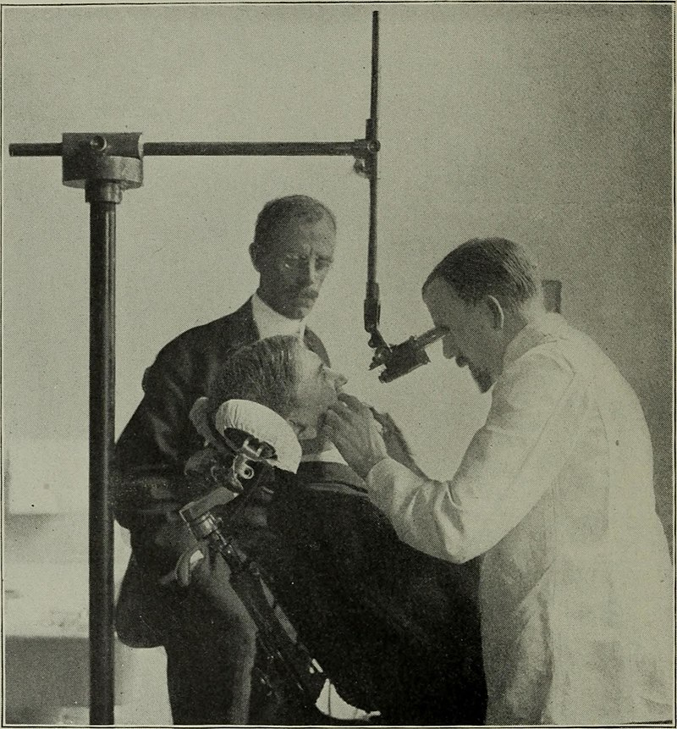

*By Internet Archive Book Images-*[*https://www.flickr.com/photos/internetarchivebookimages/14594900040/Source*](https://www.flickr.com/photos/internetarchivebookimages/14594900040/Source) *book page: https://archive.org/stream/dentalcosmos4919whit/dentalcosmos4919whit#page/n382/mode/1up, No restrictions,* [*https://commons.wikimedia.org/w/index.php?curid=43791182*](https://commons.wikimedia.org/w/index.php?curid=43791182)

*Figure 2.1: A microscopic device used in dental analysis, c. 1907*

The roots of dentistry go back as far as human civilization itself, and the earliest indications of dental practices can be traced back to a period spanning from 7000 BC to 5500 BC. (News, 2006) The field of dentistry is believed to have been the first medical specialization to emerge, eventually leading to the establishment of its own recognized degree programs and areas of expertise. (F & F, 2008)

The origin of the word dentistry can be traced back to the word dentist, which has its roots in the French word dentiste, which in turn has been derived from the French and Latin words that refer to a tooth. (Harper, 2018) The scientific discipline that deals with the study of teeth, including their structure, development, and abnormalities, is referred to as odontology.

In Bainbridge, Ohio, John M. Harris founded the world's initial dental school, which played a significant role in establishing dentistry as a health profession. The dental school was established on 21 February 1828 and currently operates as a dental museum. (Owen, Lorrie, & ed, 1999) The first dental college, Baltimore College of Dental Surgery, opened in Baltimore, Maryland, US in 1840.

It is common for dentists in numerous countries to undergo post-secondary education for a period of five to eight years before they start practicing. Even though it is not obligatory, most dentists prefer to undertake an internship or residency that concentrates on certain areas of dental care subsequent to obtaining their dental degree.

To become a certified dentist in certain nations, it is typically necessary to finish a minimum of four years of advanced studies; (purdue.edu, 2017) Dental degrees awarded around the world include the Doctor of Dental Surgery (DDS) and Doctor of Dental Medicine (DMD) in North America (US and Canada), and the Bachelor of Dental Surgery/Baccalaureus Dentalis Chirurgiae (BDS, BDent, BChD, BDSc) in the UK and current and former British Commonwealth countries.

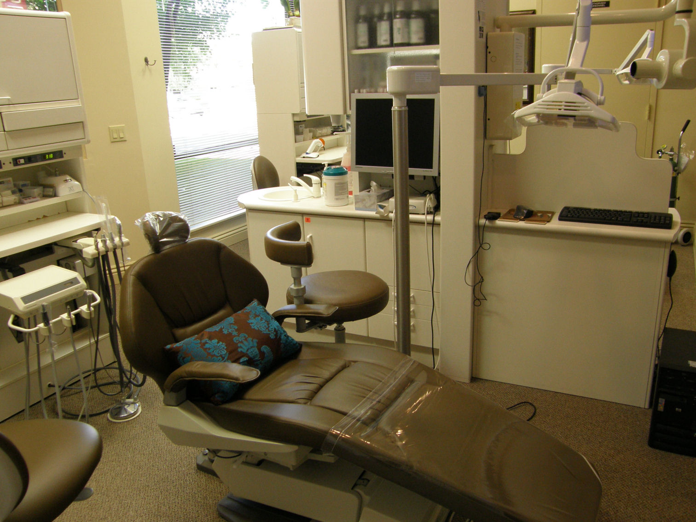

*By Own - Own work, CC BY-SA 4.0,* [*https://commons.wikimedia.org/w/index.php?curid=12596893*](https://commons.wikimedia.org/w/index.php?curid=12596893)

*Figure 2.2: Modern Dentist Chair*

## Features of Effective DCMS

## Patient Management

The term "patient management" refers to the various actions and strategies implemented by healthcare providers to meet the increasing demands of their patients. This method prioritizes building positive relationships with patients rather than solely addressing their medical conditions.

A good DCMS should be able to efficiently manage patient data, including personal information, medical history, treatment plans, and appointment scheduling.

### Electronic Health Records (EHRs)

The **electronic health record** (EHR) refers to a methodical gathering of electronically stored health information about patients and populations in a digital layout. (Gunter & Terry, 2005) DCMSs should have the capability to create, store, and retrieve electronic health records. This includes capturing clinical data, lab results, and imaging reports.

### Treatment Planning

A DCMS should have the ability to create and manage treatment plans, including the ability to assign tasks to staff members, schedule appointments, and monitor progress.

### Billing and Payment

DCMSs should be able to generate invoices and track payments, as well as process insurance claims.

### Inventory Management

DCMSs should be able to manage inventory, including tracking medical supplies and equipment, and generating alerts when supplies are running low.

### Usability

DCMSs should be user-friendly and intuitive, with clear and simple interfaces that allow staff members to quickly and easily access the information they need.

## Benefits of DCMS

DCMS (Dental Clinic Management Systems) offer several benefits to dental clinics, including:

### Improved Efficiency

DCMSs (Digital Clinic Management Systems) automate everyday tasks such as scheduling appointments, invoicing, and maintaining records. This leads to increased productivity of the clinic, saves staff's time, and minimizes the possibility of mistakes. As a result, staff can concentrate on vital responsibilities, improving the overall clinic efficiency.

### Enhanced Patient Care

DCMSs allow clinics to maintain accurate and up-to-date electronic health records for each patient. This enables dentists to provide better care and make informed treatment decisions. Additionally, DCMSs can help clinics track patient satisfaction, ensuring that patients are happy with the care they receive.

### Streamlined Operations

DCMSs provide a centralized platform for managing clinic operations, including scheduling, billing, and inventory management. This makes it easier for clinics to manage their resources and reduces the risk of confusion or errors.

### Cost Savings

DCMSs can help clinics reduce costs by streamlining operations, reducing paper usage, and minimizing the risk of errors. Additionally, DCMSs can help clinics identify areas where they can save money, such as by optimizing inventory management.

### Improved Compliance

DCMSs can help clinics comply with regulations such as HIPAA (Health Insurance Portability and Accountability Act) by ensuring the privacy and security of patient data.

## Challenges of Implementing DCMSs

While there are a lot of merits to dental clinics in general Implementing them can be challenging. Below are some of the challenges someone might face while implementing a DCMS system:

### Cost

Implementing a DCMS can be expensive, and smaller clinics may not have the financial resources to invest in the necessary hardware and software. For this reason, some clinics decide to keep using their old system, i.e., pen and paper.

### Integration

Integrating a DCMS with other systems can be challenging, particularly if the clinic is using multiple software applications. For example, if the clinic is part of a bigger organization like say a hospital, then implementing a DCMS system that suits the needs of that clinic might be challenging since it won’t probably integrate well with the existing hospital System.

### Technical Issues

DCMSs rely on technology, which can be prone to technical issues such as software bugs, hardware failures, and network outages. These issues can disrupt clinic operations and impact patient care. There clinics have to be careful and set up a backup system.

### Security

DCMSs store sensitive patient data, which can be a target for cyber-attacks. Ensuring the security and privacy of patient data is critical, and clinics must implement appropriate security measures. Which could also be costly further causing more challenges in implementing the system.

### Data Conversion

Moving from a paper-based system to a DCMS can be challenging, as it may require significant effort to convert existing patient records and other data.

If the data is too large the clinic may need to hire some data entry people which will add to the cost of implementing the system further demotivating people from moving.

## Existing Systems

### Denticon by Planet DDS // [https://www.planetdds.com/dentico //](https://www.planetdds.com/dentico%20//)

Denticon is a cloud-based dental practice management software that includes features

such as patient scheduling, treatment planning, clinical charting, billing, and reporting.

It also includes advanced features such as automated appointment reminders, patient

communications, and electronic insurance claims submission.

Planet DDS was founded in 2004 and is based in Irvine, California.

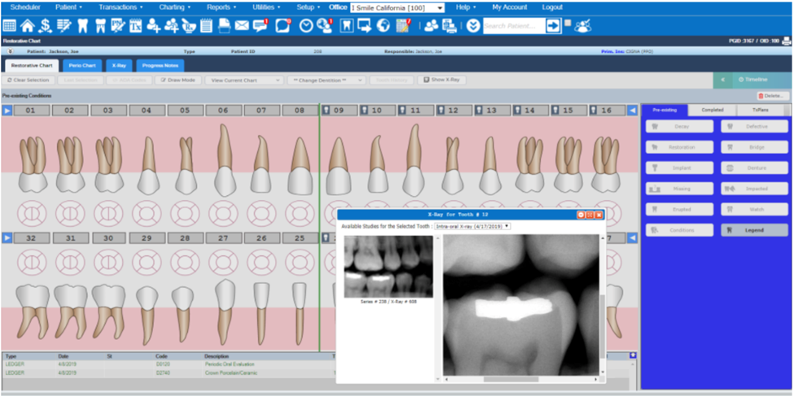

*Figure 2.3: Denticon Patient Chart with Integrated Imaging*

* Features:
  + Patient scheduling
  + Treatment planning
  + Clinical charting
  + Billing and financial reporting
  + Electronic insurance claims submission
  + Automated appointment reminders
  + Patient communication tools
* Pros:
  + Cloud-based software accessible from anywhere with an internet connection.
  + Comprehensive feature set that includes many advanced tools for managing a dental practice.
  + User-friendly interface that is easy to learn and navigate.
* Cons:
  + Pricing can be high for smaller practices or those with limited budgets.
  + Customer support can be slow to respond to requests for assistance.

### Curve Dental // <https://www.curvedental.com> //

Curve Dental is a cloud-based dental practice management software that includes

Features such as patient scheduling, clinical charting, electronic prescriptions, and billing.

It also includes advanced features such as patient communication, electronic insurance claims submission, and a patient portal.

Curve Dental was founded in 2004 and is based in Orem, Utah.

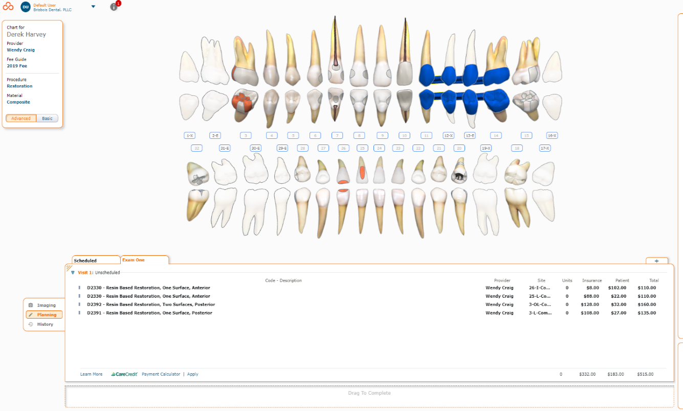

*Figure 2.4: Curve Hero | Charting*

* Features:
  + Patient scheduling
  + Clinical charting
  + Electronic prescriptions
  + Billing and financial reporting
  + Patient communication tools
  + Electronic insurance claims submission
  + Patient portal
* Pros:
  + Cloud-based software accessible from anywhere with an internet connection.
  + Strong focus on user experience and design, with an intuitive interface that is easy to use.
  + Offers a free trial and affordable pricing options.
* Cons:
  + Limited integrations with other dental software or third-party services.
  + Some users report occasional performance issues or slow load times.

### Open Dental // <https://www.opendental.com> //

Open Dental is a comprehensive dental practice management software that includes

features such as patient scheduling, treatment planning, clinical charting, billing, and reporting.

It also includes advanced features such as electronic prescriptions, patient communication, and electronic insurance claims submission.

Open Dental was founded in 2003 and is based in Salem, Oregon.

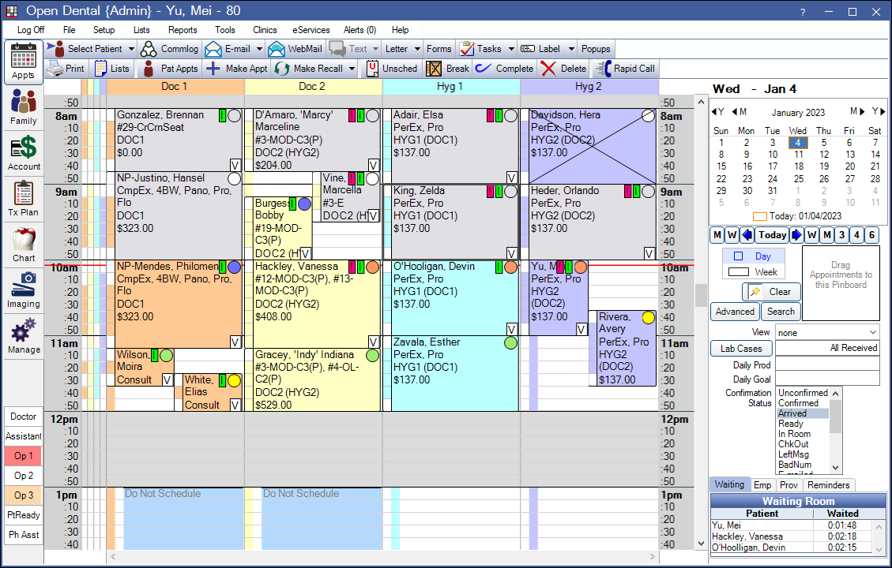

*Figure 2.5: Appointments Module. Used for managing appointments. Image displays examples of scheduled appointments and includes appointment-related features, such as the Pinboard and calendar.*

* Features:
  + Patient scheduling
  + Treatment planning
  + Clinical charting
  + Billing and financial reporting
  + Electronic prescriptions
  + Patient communication tools
  + Electronic insurance claims submission
* Pros:
  + Offers a wide range of features and customization options for dental practices of all sizes.
  + Affordable pricing options, with a free trial available.
  + Strong focus on open source and community support.
* Cons:
  + Requires more technical expertise to set up and maintain than some other dental software options.
  + User interface can be less intuitive than other software platforms.

### Eaglesoft by Patterson Dental // <https://www.eaglesoft.net> //

Eaglesoft is a comprehensive dental practice management software that

includes features such as patient scheduling, treatment planning, clinical charting, billing, and reporting.

It also includes advanced features such as patient communication, electronic insurance claims submission, and a patient portal.

Patterson Dental was founded in 1877 and is based in St. Paul, Minnesota.

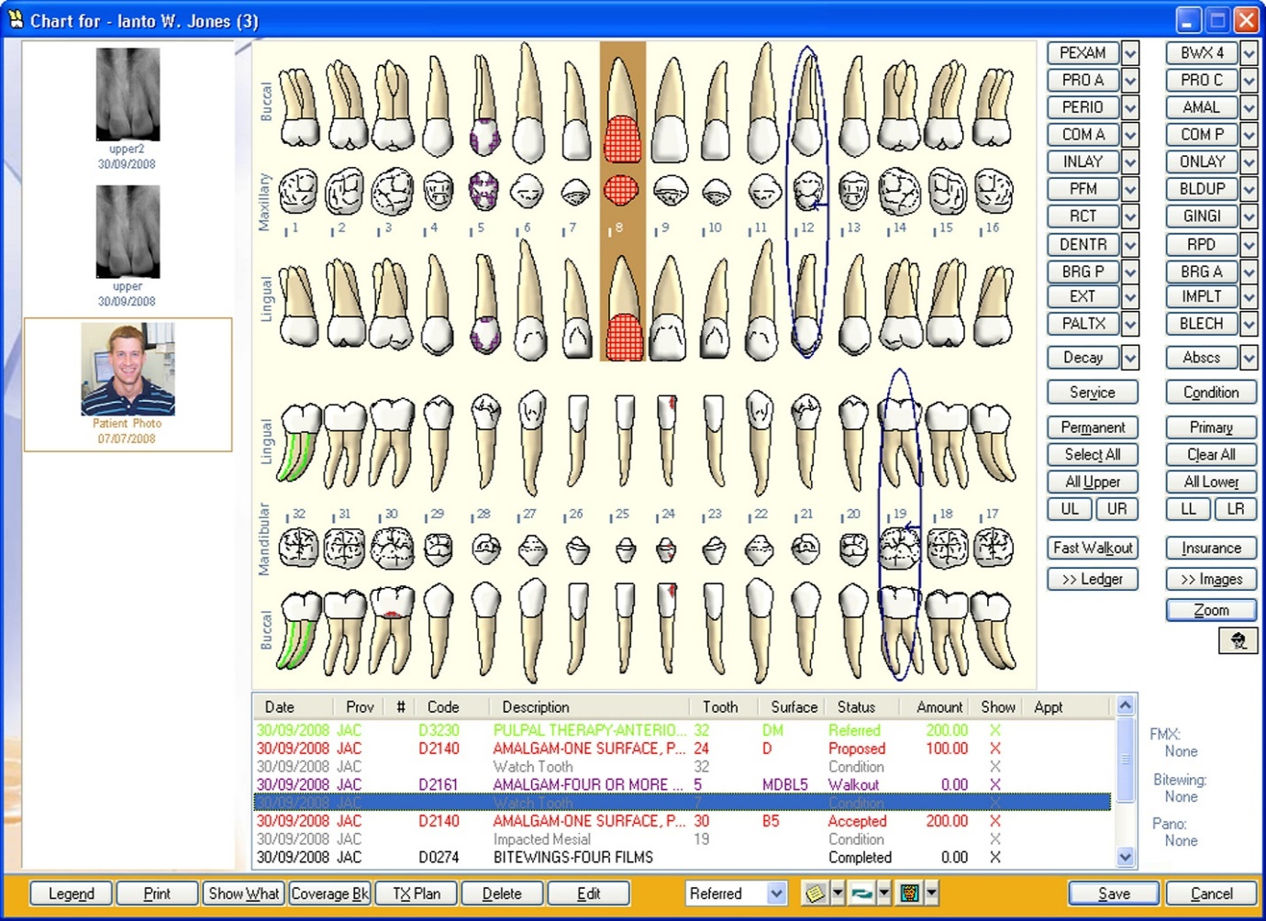

*Figure 2.6: EagleSoft | Chart*

* Features:
  + Patient scheduling
  + Treatment planning
  + Clinical charting
  + Billing and financial reporting
  + Patient communication tools
  + Electronic insurance claims submission
  + Patient portal
* Pros:
  + Comprehensive feature set that includes many tools for managing a dental practice.
  + Strong customer support, with live phone and chat support available.
  + Integrates with a wide range of other dental software and services.
* Cons:
  + Pricing can be high, particularly for smaller practices or those with limited budgets.
  + Some users report occasional performance issues or slow load times.

### Dentrix by Henry Schein One // <https://www.dentrix.com> //

Dentrix is a comprehensive dental practice management software that includes

features such as patient scheduling, treatment planning, clinical charting, billing, and reporting.

It also includes advanced features such as patient communication, electronic insurance claims submission, and a patient portal.

Henry Schein One was formed in 2018 and is based in American Fork, Utah.

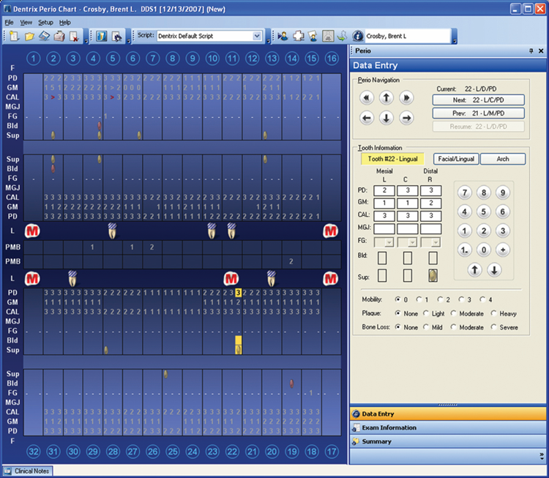

*Figure 2.7: Dentrix data entry*

* Features:
  + Patient scheduling
  + Treatment planning
  + Clinical charting
  + Billing and financial reporting
  + Patient communication tools
  + Electronic insurance claims submission
  + Patient portal
* Pros:
  + Comprehensive feature set that includes many advanced tools for managing a dental practice.
  + Strong focus on integrations, with many third-party software and services available.
  + User-friendly interface that is easy to learn and navigate.
* Cons:
  + Pricing can be high for smaller practices or those with limited budgets.
  + Some users report occasional performance issues or slow load times.

## Summary

Chapter two of the thesis provides an in-depth review of the literature related to dental clinic management systems (DCMSs). It begins by discussing the importance of dental care and the challenges in accessing quality services in many parts of the world. The chapter then outlines the key features and functionalities of effective DCMSs, including appointment scheduling, patient record management, billing and payment processing, inventory management, and reporting and analysis. The benefits of DCMSs are also discussed, such as improved efficiency, quality of care, and patient satisfaction.

However, the chapter also highlights the challenges of implementing DCMSs, including technological and financial barriers, staff resistance, and lack of training and support. Other topics covered in the chapter include the role of foreign direct investment (FDI) in DCMSs, the use of cloud-based systems, and the potential for mobile and telemedicine technologies in expanding access to dental care. Overall, the literature review provides a comprehensive overview of the current state of DCMSs and highlights the importance of addressing the challenges in implementing these systems to improve access to quality dental care.

# METHODOLOGY

## INTRODUCTION

This chapter describes the study process, which comprises the Operational Framework, Work Breakdown Structure, Identification of System Requirements and Problem Analysis, Process Modelling, Data Modelling, and System Feasibility.

## Operational Framework

An operational framework aids in making sure the software development process is organized, effective, and efficient. It gives developers a roadmap to follow, which makes it easier to make sure the product is timely supplied and satisfies the demands of customers and stakeholders.

### System development life cycle

In systems engineering, information systems and software engineering, the systems development life cycle (SDLC), also referred to as the application development life cycle, is a process for planning, creating, testing, and deploying an information system, The SDLC concept applies to a range of hardware and software configurations, as a system can be composed of hardware only, software only, or a combination of both. (Parag, James, & Girish, 2008)

The SDLC process involves several distinct stages, including planning, analysis, design, Implementation and maintenance.

SDLC provides a set of phases/steps/activities for system designers and developers to follow; we use the iterative model approach.

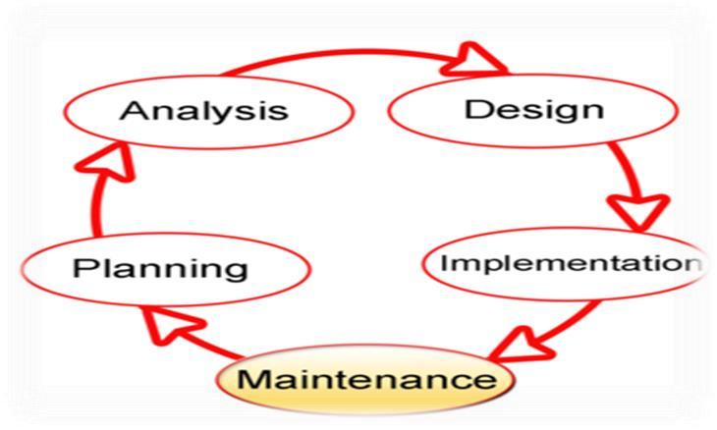

*Figure 3.1 Model of the software development life cycle*

### Iterative Model

The Iterative Model is a software development methodology that involves a cyclical approach to the software development life cycle (SDLC). In this model, the development process is broken down into a series of iterations, with each iteration building on the previous one. (Sommerville, 2016)

The Iterative Model in Software Engineering typically involves the following steps:

1. Requirements: The first step involves gathering requirements from stakeholders and users.
2. Planning: Based on the requirements, a plan is created for the development process.
3. Design: The design phase involves creating a detailed plan for the software.
4. Development: In this step, the actual development of the software begins.
5. Testing: After the software is developed, it is rigorously tested to ensure that it meets the requirements.
6. Deployment: Once the software is tested and ready, it is deployed to the end-users.
7. Evaluation: The final step involves evaluating the software and gathering feedback from users and stakeholders to improve it.

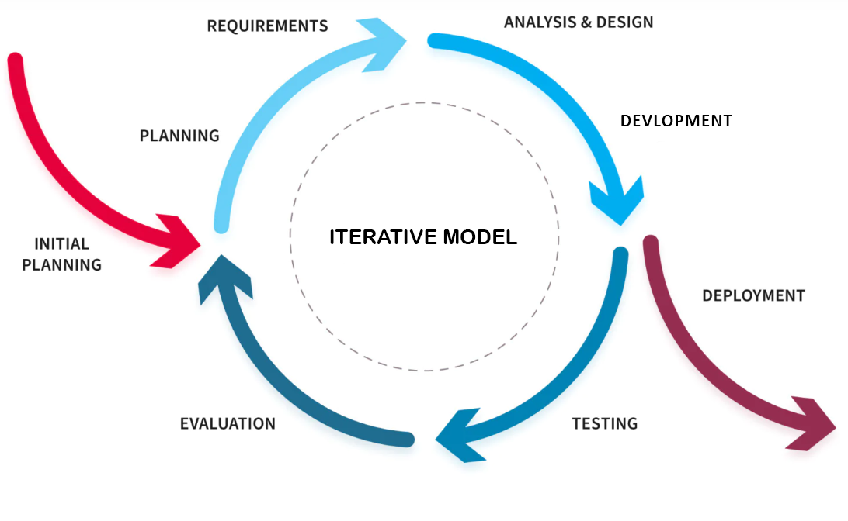

*Figure 3.2 The Iterative Methodology*

## Work breakdown Structure

A work-break structure (WBS) is a deliverable-oriented breakdown of a project into smaller components. A work breakdown structure is a key project deliverable that organizes the team's work into manageable sections. (D, 2014)

It is common for work breakdown structure elements to be numbered sequentially to reveal the hierarchical structure. The purpose of the numbering is to provide a consistent approach to identifying and managing the WBS across like systems regardless of vendor or service, (Defense, 2011)

To apply a WBS to our project, we shall divide our labor into the following groups: The four basic divisions of the application project that make the most sense is database architecture, mobile application development, web application development, and implementation.

Developing a Dental clinic Mobile app and Web app

1. Database

* 1. Appointments
  2. Drugs
  3. Expenses
  4. Expenses Drug View
  5. Patients
  6. Payments
  7. Salary
  8. Services
  9. Show Appointments
  10. Staff
  11. Users

1. Mobile App Features
   1. Bookings
   2. Directions
   3. Push Notifications
   4. Contact Form

1. Web app Features

The Web app Has Two Sides Admin Side & Staff Side

* 1. Admin Side

3.1.1 Schedule Appointment

3.1.2 Manage Appointments List

3.1.3 Service List

3.1.4 Manage Services

3.1.5 Users list

3.1.7 Manage Users

3.1.8 Login & Logout

3.1.9 Expenses List

3.1.10 Manage Expense

3.1.11 Patients List

3.1.12 Manage Patients

3.2 Staff Side

3.2.1 Login & Logout

3.2.2 Schedule Appointment

3.2.3 Patients List

3.2.4 Manage Patients

3.2.5 Manage Account

## System Requirement

System requirements in software engineering refer to the detailed specifications that describe what the software system should do and how it should perform.

### Software Requirement

A software requirement is a statement that describes a specific function, feature, capability, or quality that a software system must possess in order to fulfil its intended purpose.

According to IEEE standard 729 A software requirement can be of 3 types:

* Functional requirements
* Non-functional requirements
* Domain requirements

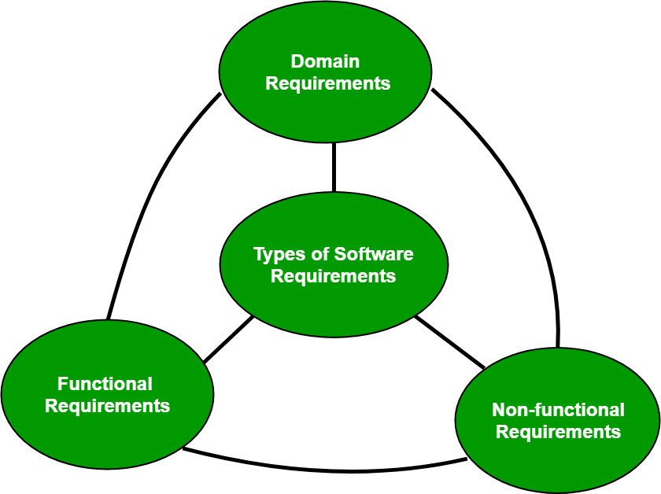

*Figure 3.3 Types of Software Requirements*

#### Functional Requirements

These are the specifications that the system must meet in order to satisfy the end user's fundamental needs. A system's likely purpose can be determined by a computation, data manipulation, business process, user interaction, or any other specialized feature.

#### Non-Functional Requirements

These are basically the quality constraints that the system must satisfy according to the project. Non-functional requirements, not related to the system functionality, rather define how the system should perform the priority or extent to which these factors are implemented varies from one project to other. They are also called non-behavioral requirements. They basically deal with these issues:

Portability

Security

Maintainability

Reliability

Scalability

Performance

Reusability

Flexibility

#### **Domain Requirements**

Domain requirements are the requirements which are characteristic of a particular category or domain of projects Functional or non-functional domain requirements might exist. Domain requirements engineering is a continual process of proactively specifying the requirements for all anticipated software product line applications. This category includes the fundamental functions that every system in a certain area must have.

### User Requirement Definition

The demands and expectations of software system users or stakeholders are referred to as user requirements. User requirements are an important part of software development since they form the basis for developing, implementing, and testing the software system. (IEEE, 1998)

User requirements also can be categorized into two types: functional and non-functional requirements, Non-functional requirements explain how the software system should work, while functional requirements describe the exact activities, features, and capabilities that the software system should do. (IEEE, 1998)

A high-performance software system must also have an appealing, clear, consistent, and responsive user interface. Otherwise, the functionality of the software system will be hard to utilize. It is regarded outstanding if a system allows you to use it efficiently.

## Problem analysis identification

Problem analysis is a series of steps for identifying problems, analyzing them, and developing solutions to address them. It's an inquiry or investigation into the causes of an error, failure, or unexpected incident. While the major aim of issue analysis is to develop solutions, the process also provides you with an in-depth understanding of a problem that enables you to prevent other kinds of problems that might arise from the same cause. (Indeed Editorial Team, 2022)

## Requirement Gathering Techniques

Requirements gathering is one of the most essential parts of any project and adds value to a project on multiple levels. When it comes to smaller budgets, tighter timelines and limited scopes, exact documentation of all the project requirements become crucial. Requirements gathering is easier said than done, it is generally an area that is given far less attention than it needs. Many projects start with basic lists of requirements only to find out down the line that many of the customers’ needs may not have been fully understood and implemented. Statistics show that over 70% of failed projects are a result of a lack of effective requirements gathering. (reqtest, 2020)

### Interview

The interview is defined as the method of asking questions to gain both qualitative and quantitative data. In quantitative questions, interviewees select their choices in a limited range of responses provided by the researcher, on the other hand, qualitative questions aim to obtain the interviewee's descriptions to a specific question. Although there are different methods for qualitative data collection such as text or document reviews, diaries, and participant observation, interviews are the most commonly used techniques for primary qualitative data collection as they provide a natural and comfortable atmosphere for the participants. (Taherdoost, 2022)

### Observation

Observation method is described as a method to observe and describe the behavior of a subject and it involves the basic technique of simply watching the phenomena until some hunch or insight is gained. We are almost constantly engaged in observation. "It is our basic method of obtaining information about the world around us”. (Ankit, 2022)

## Process modeling

Process modeling is the graphical representation of business processes or workflows. Like a flow chart, individual steps of the process are drawn out so there is an end-to-end overview of the tasks in the process within the context of the business environment.   A process model allows visualization of business processes so organizations can better understand their internal business procedures so that they can be managed and made more efficient. This is usually an agile exercise for continuous improvement. Process modeling is a vital component of process automation, as a process model needs to be created first to define tasks and optimize the workflow before it is automated. (Claire, 2020)

### Data Flow Diagram

A data flow diagram (DFD) is a graphical or visual representation using a standardized set of symbols and notations to describe a business's operations through data movement. They are often elements of a formal methodology such as Structured Systems Analysis and Design Method (SSADM). Superficially, DFDs can resemble flow charts or Unified Modeling Language (UML), but they are not meant to represent details of software logic. (Nolle, 2021)

### Unified Modeling Language (UML)

The Unified Modeling Language (UML) is a standard language for writing software blueprints. The UML may be used to visualize, specify, construct, and document the artifacts of a software-intensive system.

The UML is appropriate for modeling systems ranging from enterprise information

systems to distributed Web-based applications and even to hard real time embedded systems. It is a very expressive language, addressing all the views needed to develop and then deploy such systems. Even though it is expressive, the UML is not difficult to understand and to use.

Learning to apply the UML effectively starts with forming a conceptual model of the language, which requires learning three major elements: the UML's basic building blocks, the rules that dictate how these building blocks may be put together, and some common mechanisms that apply throughout the language. (Grady, James, & Ivar, 2005)

#### **Use Case Diagram (UCD)**

A use case diagram is a visual summarization of interactions and relationships within a system. These diagrams show a very broad view of a system. They may show systems in computer software, businesses or customer experiences. A use case diagram shows a model scenario in which individuals interact with a system using a series of specialized symbols and connectors. (Indeed Editorial Team, 2022)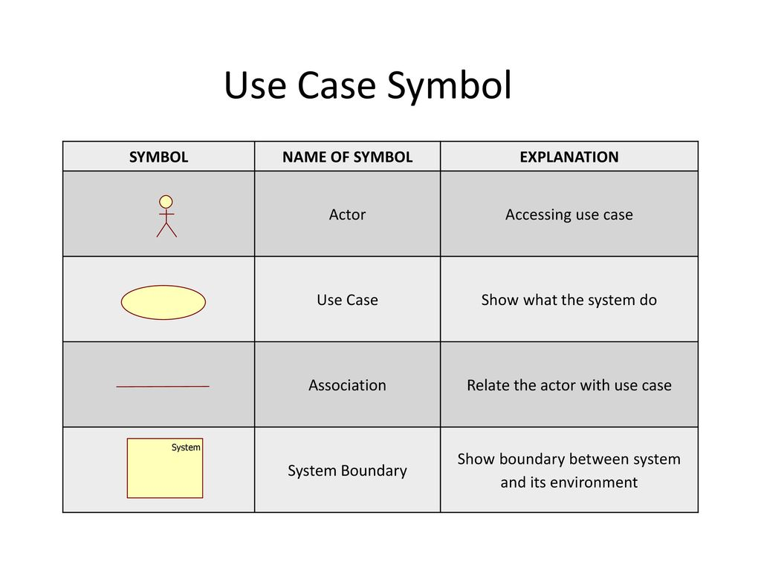

Figure 3.6.2.1 some symbols of UCD ( <https://player.slideplayer.com/78/12881923/slides/slide_23.jpg> )

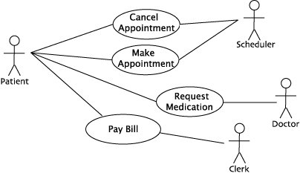

Figure 3.6.2.2 example of UCD ( <https://twu.seanho.com/11spr/cmpt166/uml/usecasesimple.gif> )

## Data Modeling

The process of conceptually representing data objects, their connections to one another, and the principles governing those connections is known as data modeling. It entails correctly reflecting the real-world objects or processes that the data represents in the definition of the data structure. In order to make sure that the data is arranged and accessible in an effective and logical way, this method is frequently used in database design. Various methods, such as entity-relationship diagrams (ERDs), UML diagrams, and data flow diagrams (DFDs), can be used to represent data. A crucial stage in the development of many software systems, the resulting data model serves as a guide for building databases.

### Entity Relationship Diagram (ERD)

In a data model, entities and their connections to one another are graphically represented by Entity Relationship Diagrams (ERDs). A database's layout can be designed and analyzed with the aid of this visual utility. Entities, attributes, and relationships make up the core three elements of the ERD.

1. Entities are objects or concepts that have a distinct existence and are represented as rectangles in an ERD.
2. Relationships define the connections between entities and are represented as diamond shapes connected by lines to the related entities.
3. Attributes are characteristics of an entity and are represented as ovals connected to the corresponding entity by lines.

ERDs are used a lot in database design to specify the entities and connections that should be present in the database and to visualize how data should be accessed and saved. They can be applied to make sure the database layout is effective, precise, and fulfills the requirements of the system and its users.

#### **Entity Relationship Diagram (ERD) Symbols.**

The various elements of an entity relationship diagram, such as entities, traits, and connections, are represented by the ERD symbols. The typical ERD symbol and their significance are as follows:

1. Entity: represented as a rectangle with rounded corners, with the entity name written inside.
2. Attribute: represented as an oval connected to the corresponding entity by a line, with the attribute name written inside the oval.
3. Primary key: represented as an underlined attribute or a bolded attribute, indicating that it uniquely identifies the entity.
4. Foreign key: represented as an attribute with an arrow pointing to the related entity, indicating that it references the primary key of another entity.
5. Relationship: represented as a diamond shape connected by lines to the related entities. The relationship name is written inside the diamond, and the cardinality and optionality are written on each end of the lines connecting the diamond to the entities.
6. Cardinality and optionality: represented by symbols on each end of the relationship lines. Common symbols include "1" for one-to-one relationships, "M" for many-to-one relationships, and "N" for many-to-many relationships. Optionality is represented by "o" for optional and "M" for mandatory.

#### **Types Of Relationships**

There are many different kinds of relationships that can occur between entities in entity relationship modeling. These relationships help define how the entities are related to each other and how they interact within the system. The main relationship types are as follows:

1. One-to-One (1:1) Relationship: In this type of relationship, each record in one entity is related to only one record in the other entity, and vice versa. For example, each employee can have only one assigned workstation, and each workstation can only be assigned to one employee.
2. One-to-Many (1:N) Relationship: In this type of relationship, each record in one entity can be related to one or many records in the other entity, but each record in the other entity can be related to only one record in the first entity. For example, each customer can place many orders, but each order is placed by only one customer.
3. Many-to-One (N:1) Relationship: In this type of relationship, each record in one entity can be related to only one record in the other entity, but each record in the other entity can be related to one or many records in the first entity. For example, each employee is assigned to one department, but each department can have many employees.
4. Many-to-Many (N:N) Relationship: In this type of relationship, each record in one entity can be related to many records in the other entity, and vice versa. For example, each student can enroll in many courses, and each course can have many students.

## System Feasibility

System feasibility is the process of assessing a suggested system's organizational, technological, and fiscal viability in order to decide whether it is worthwhile to spend resources in it. This entails carrying out a viability study to determine whether the system can be developed and executed with the resources at hand, within the allotted time frame, and whether it will satisfy the requirements of the users and the organization. A cost-benefit analysis, technological needs, resource availability, effect on the organization and its users, and interoperability with current systems and processes are just a few examples of the elements that the study should take into account. The choice of whether to move forward with the project or to discontinue it is made in light of the findings of the feasibility study.

### Technical Feasibility

One of the elements of system feasibility is technical feasibility, which is the evaluation of whether a suggested system can be created and implemented using the current technology and resources. It entails assessing the technological specifications of the system, including its hardware, software, and network architecture, and determining whether they can be met given the project's time, financial, and resource limitations.

The availability of necessary hardware and software components, the proposed system's compatibility with the existing technology infrastructure, and the degree of technical expertise needed to develop and maintain the system are all factors taken into account during a technical feasibility analysis. The technological viability study also considers whether the system can be adjusted up or down as required in the future as well as how well it meets performance, security, and dependability standards.

**Table 3.1: Technical Feasibility**

|  |  |  |  |  |
| --- | --- | --- | --- | --- |
| NO | Name | Quantity | Description | Price |
| 1 | Computer | 1 | 500GB SSD,  16GB RAM,  I7 Processor:  Intel® Core™  CPU | Around: $600 USD |
|  |  |  |  |  |

### Operational Feasibility

The evaluation of a proposed system's operational feasibility determines whether it can be successfully incorporated into the current organization and its operations. It establishes whether the proposed system will be in line with the organization's goals, rules, and practices. It also assesses the staff's capacity to successfully use and handle the system.

The expenditure of system user guidance is shown in the table below.

**Table 3.2 Operational Feasibility**

|  |  |  |
| --- | --- | --- |
| Activities | Duration | Expected Cost |
| Training Current Employee | 1 Week | $300.00 |
| Training New Employee | 2 Week | $600.00 |
| Total |  | $900.00 |

### Schedule Feasibility

The ability of the project to be finished within the specified timeframe or plan is referred to as schedule feasibility. It entails deciding whether the project can be finished in a fair and appropriate amount of time while taking into account various aspects like resource access, project intricacy, and scope.

Due to the time limit imposed on the thesis, we will have to work our schedule around the available time frame.

## Chapter Summary

In this chapter, we have talked about the system requirement and Process Modeling as well as the Data Modeling. We also talked about the System Feasibility and their types.

# SYSTEM DESIGN

## INTRODUCTION

The main goal of the Dental Clinic Management System (DCMS) is to modernize and enhance the management and operational processes of a dental clinic. This chapter outlines our approach to addressing the challenges associated with dental clinic management and developing a comprehensive system to address these issues. It also highlights the underlying assumptions and reasoning that guided our design decisions.

The system design presented in this chapter serves as a crucial framework for developing the appropriate software programs. It provides a descriptive overview of the software design and encompasses both the internal and external aspects of the application, serving as a guide for the development process.

## Architectural Design

The system design of DCMS begins with a multi-tier architecture that separates the web and mobile components. The web part of the system serves as the management interface for employees, dentists, staff, and other authorized users. It provides functionalities such as appointment scheduling, patient management, billing and invoicing, inventory management, and reporting. The mobile part of the system, designed for patients, allows them to book appointments, make payments, view their appointments, access dental records, and receive notifications.

## User Interface

The user interface (UI) of DCMS is designed to be intuitive and user-friendly, ensuring a seamless experience for both the clinic's staff and the patients.

## Web Interface

The web interface of DCMS provides a full set of features and functionalities for the clinic's management. It offers a dashboard that displays relevant information and quick access to key modules, such as appointment management, patient records, and inventory control. The UI is designed with a clean and organized layout, allowing users to navigate easily and perform their tasks efficiently. User roles and permissions are implemented to ensure secure access and appropriate levels of authority for different users.

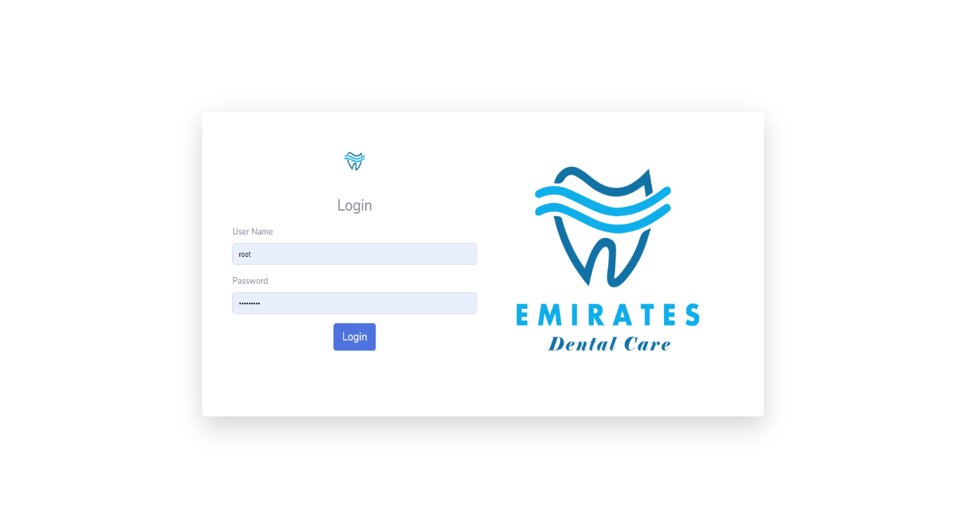

Figure 4.2.1 (A) Web Login Page

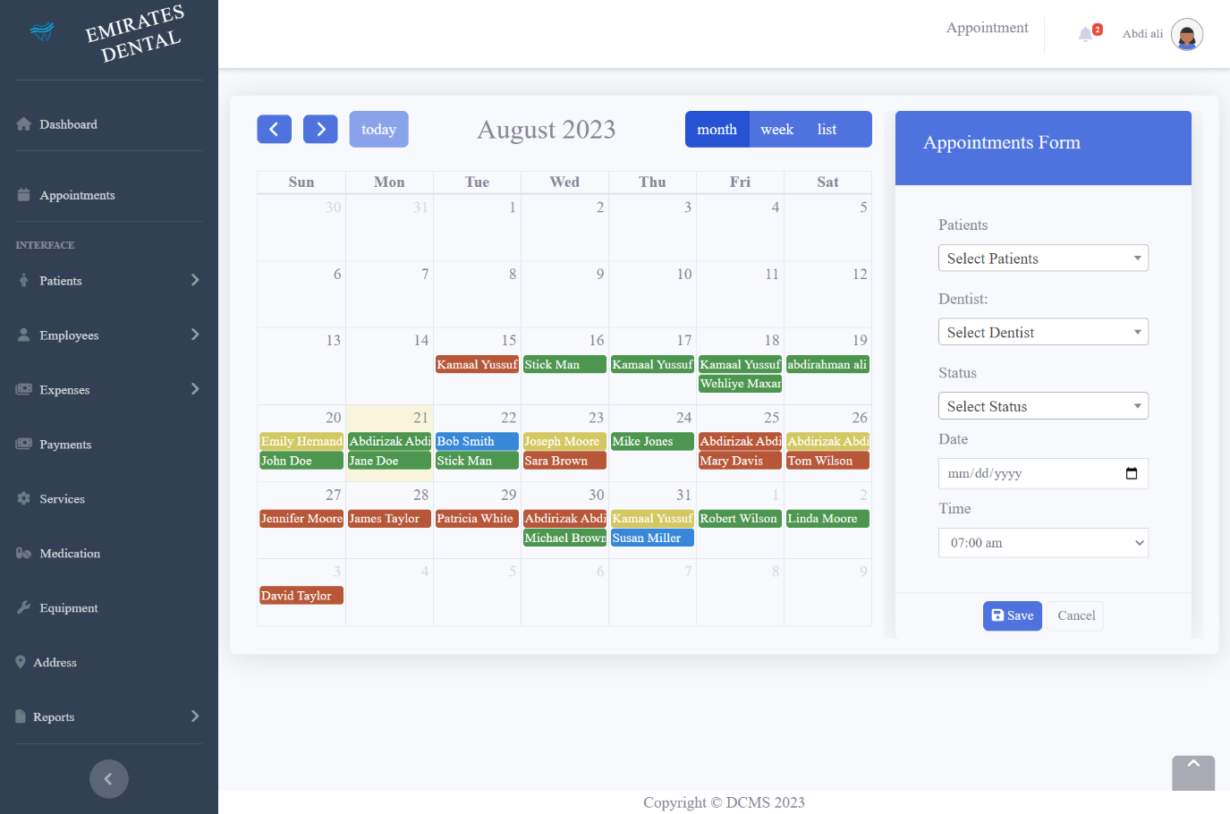

Figure 4.2.1 (B) Appointments Interface

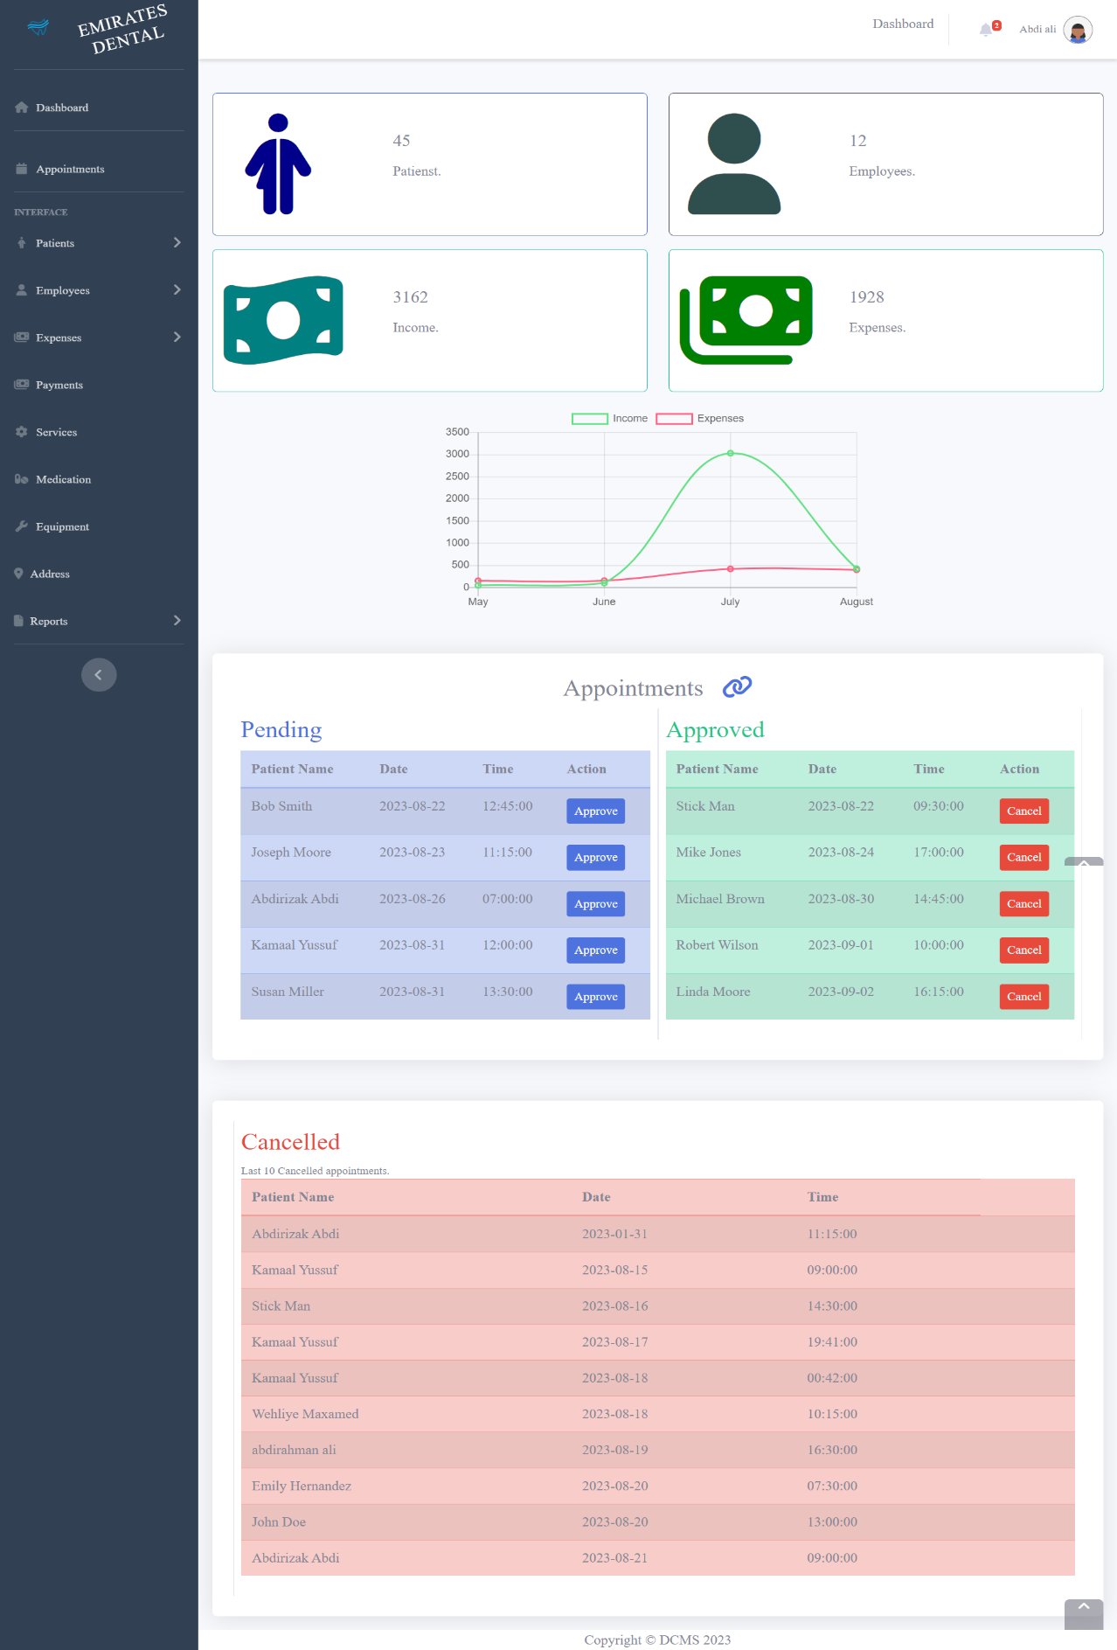

Figure 4.2.1 (C) Web Interface dashboard

## Mobile Interface

The mobile interface of DCMS is tailored specifically for patients, enabling them to interact with the system on their smartphones. The mobile app offers a user-friendly interface that allows patients to book appointments based on available time slots, make payments, view their upcoming and past or canceled appointments, access their dental records, and receive timely notifications and reminders.

The mobile interface design prioritizes simplicity, ease of use, and responsiveness to ensure a positive user experience.

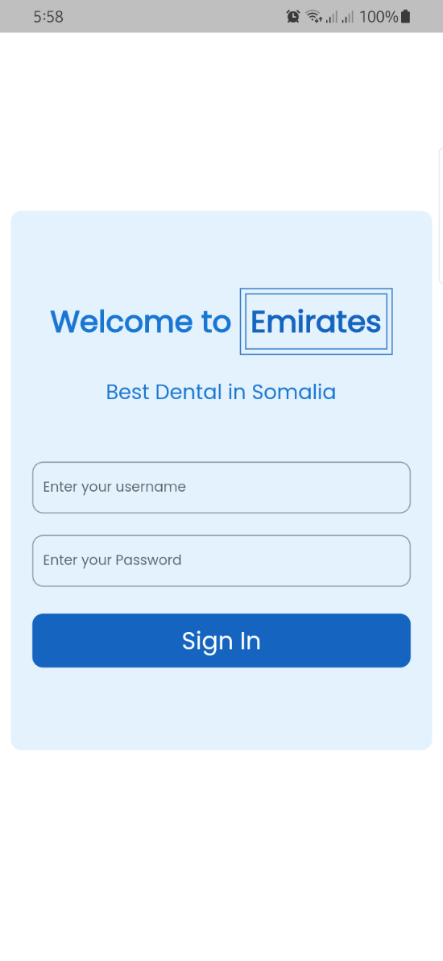

Figure 4.2.2 (A) Login Interface Mobile App

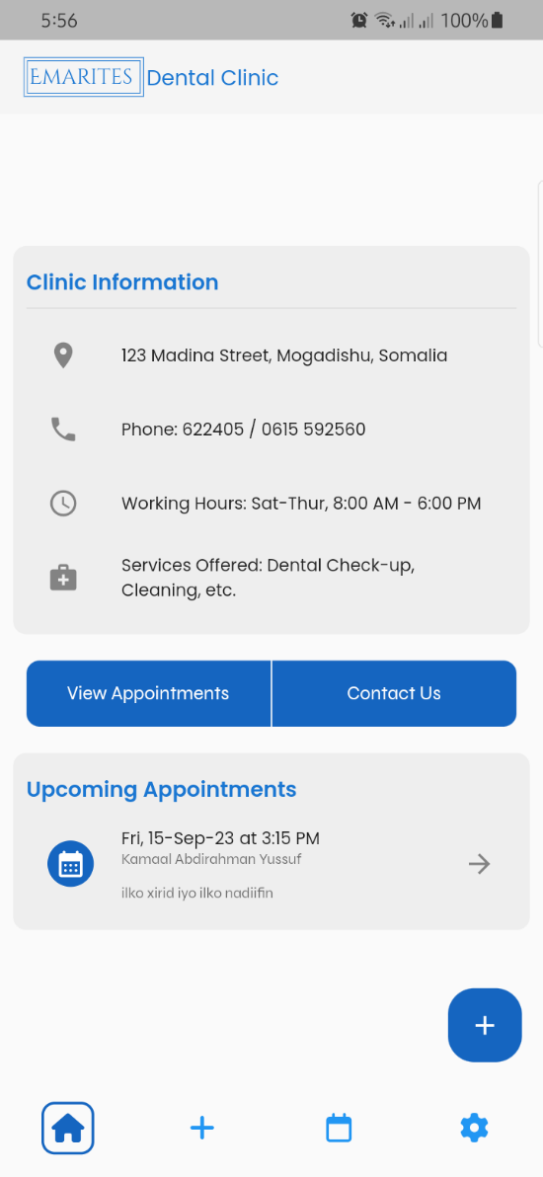

Figure 4.2.2 (B) Home Page Interface Mobile App

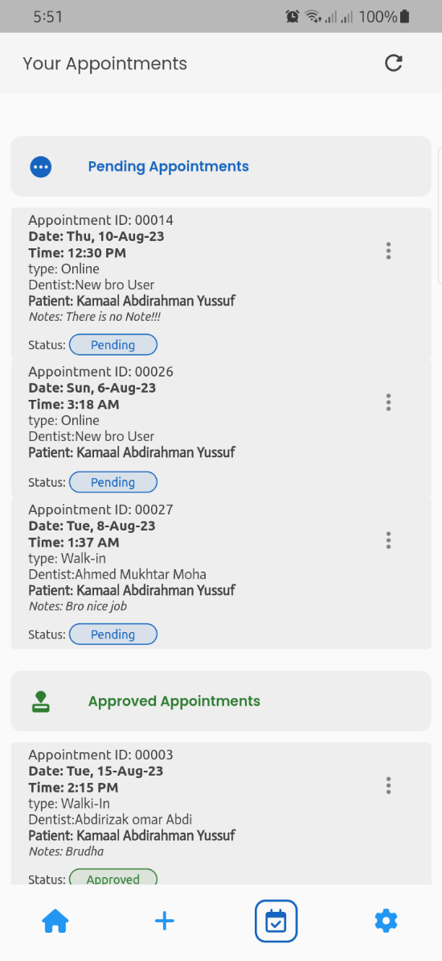

Figure 4.2.2 (C) Appointments Interface Mobile App

## Database Storage Design

The developers of the application utilized the MySQL database storage platform to establish the application's database by employing query and manual techniques. Throughout this process, they meticulously designed and constructed database columns and tables, encompassing a total of Twenty tables and 9 Views that were specifically tailored to cater to the requirements of our application.

MySQL was chosen for its cost-effectiveness and flexibility. It is free to use and modify, and it can be scaled to meet the needs of a growing application. The use of MySQL has allowed the application to store large amounts of data efficiently, which has enabled the application to provide a high-quality user experience. A visual representation of these tables is presented in the accompanying figure.

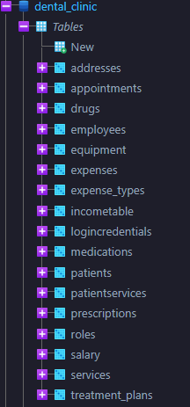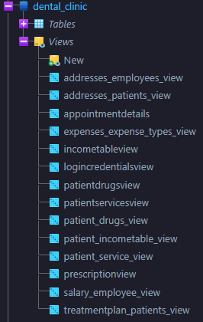

Figure 4.3 Database Tables and Views

## Database Design

The process of designing a database entails the conceptualization and representation of an actual system that encompasses various entities along with their corresponding attributes and the rules or associations that exist among these entities.

The design process typically includes the following phases:

1. **Planning**: This phase involves identifying the data requirements of the system and defining the scope of the database.
2. **Modeling**: This phase involves creating a conceptual model of the database, which is a graphical representation of the entities, attributes, and relationships in the system.
3. **Implementation**: This phase involves creating the physical database, which is the actual database that will store the data.
4. **Normalization** is a technique for improving the design of a database by reducing redundancy and ensuring that the data is consistent. The normalization process involves dividing the database into smaller tables, each of which contains a single entity. The tables are then linked together by relationships, which define how the data in the tables is related.

In the database design described in the text, the developers followed the normalization process to create a well-organized and efficient database. This will make the database easier to use and maintain, and it will reduce the risk of data errors.

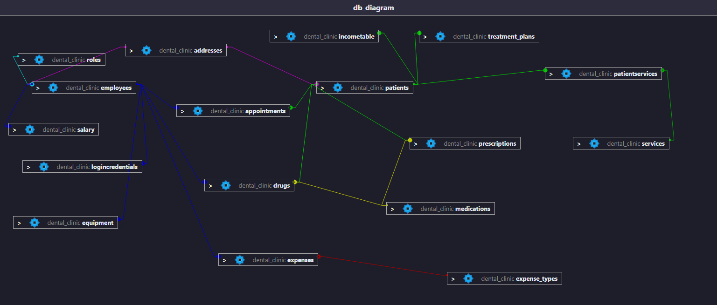

Figure 4.4 Database Design Diagram

## Database Normalization

Database normalization is a process of organizing data in a database to reduce data redundancy and improve data integrity. This process involves a series of steps known as normal forms. It is done by dividing the database into smaller tables, each of which contains a single entity. The tables are then linked together by relationships, which define how the data in the tables is related. The initial step is referred to as the first normal form (1NF).

The first normal form (1NF) is the first level of database normalization. A table in 1NF satisfies the following conditions:

1. Each column contains atomic values.
2. Each row is unique.

Atomic values are values that cannot be broken down into smaller units. For example, the value "123 Main Street" is an atomic value, but the value "123" is not, because it can be broken down into the atomic values "1", "2", and "3".

Each row in a table must be unique. This means that no two rows in the table can have the same values for all of the columns.

Once a table is in 1NF, it can be further normalized to higher levels of normalization, such as 2NF and 3NF. Each higher level of normalization adds additional constraints to the table, which further reduces data redundancy and improves data integrity.

Here we have an example of a table that we will normalize to third normal form.

This table is the employee table before any normalization has taken place.

|  |  |  |  |  |  |
| --- | --- | --- | --- | --- | --- |
| Name | Email | Phone | Address | Role | Hire\_date |
| Abdi Omar | [abdi@gmail.com](mailto:abdi@gmail.com),  omar@gmail.com | 612226222 | Danwadaagta, Madina. | Dentist | 1/1/2022 |
| Amina Mohamed | amina@gmail.com | 636363646 | Buula Xubey, Madina | Staff | 1/1/2022 |

## Frist Normal Form

The rules for first normal form are as follows:

1. All values in a column should be atomic. As you can see above, some columns like address have multiple values. For a table to be in first normal form, each column must have only one value.
2. Each row is unique.

After 1NF in Table Employees

|  |  |  |  |  |  |  |
| --- | --- | --- | --- | --- | --- | --- |
| First Name | Second Name | Email | Phone | Address | Role | Hire\_date |
| Abdi | Omar | abdi@gmail.com | 612226222 | Danwadaagta, Madina. | Dentist | 1/1/2022 |
| Abdi | omar | omar@gmail.com | 612226222 | Danwadaagta, Madina. | Dentist | 1/1/2022 |
| Amina | Mohamed | amina@gmail.com | 636363646 | Buula Xubey, Madina | Receptionist | 1/1/2022 |

So now, all the rows are unique since the table has a composite key(name and phone) field and all cell are single valued (almost all).

## Second Normal Form

The Rules for second normal form are as follows:

1. The table should be in first normal form.
2. Eliminate partial dependencies. This means that each non-key column should depend on the entire primary key, rather than just a part of it. If a column depends on only a subset of the primary key, it should be moved to a separate table.

For example, the job, role, and address columns are only related to the employee e.g. employee name. they have nothing to do with email or phone which make up part of the composite key. Therefore, those should have a table of their own.

That means we will have Five separate tables.

1. Address
2. Role
3. Employee(original table)
4. Address table

|  |  |  |  |
| --- | --- | --- | --- |
| Address\_id | street | city | state |
| 1 | Buula Xubey | Mogadishu | Benadir |
| 2 | Danwadaagta | Mogadishu | Benadir |

1. Roles table

|  |  |  |
| --- | --- | --- |
| Role\_id | Name | Description |
| 1 | Receptionist | Register People |
| 2 | Dentist | Dentist |

1. Employee table

|  |  |  |  |  |  |  |  |
| --- | --- | --- | --- | --- | --- | --- | --- |
| Employee\_id | First name | Second name | Email | Role | Address | Phone | Hire\_date |
| 1 | Abdi | Omar | abdi@gmail.com | 2 | 1 | 612226222 | 1/1/2022 |
| 2 | Amina | Mohamed | [amina@mail.com](mailto:amina@mail.com) | 1 | 2 | 636363646 | 1/1/2022 |

## Third Normal Form

The rules of the third normal for are as follows:

* + - 1. Table should be in second normal form.
      2. Has no transitive functional dependencies. A transitive dependency occurs when a non-key column depends on another non-key column instead of directly depending on the primary key.
         1. A table is in 3NF if it is in 2NF and no non-prime attribute is transitively dependent on the primary key. A non-prime attribute is an attribute that is not part of the primary key. A transitive dependency is a dependency between two attributes where one attribute is dependent on another attribute, and the second attribute is dependent on the primary key. For example if the the qualification field in the dentist table was dependent of the specialty then the table would not be in 3NF, this is because, Specialty is not part of primary there maybe other dentists with the same specialty but with different qualifications.

Following the rules of the third normal form we see that our table is already in 3NF since we don’t have any transitive dependence.

## Converting ER diagrams into relational representations.

Now that we have a normalized database all that is left do is Transform the ER Diagrams into relational database. Below are the ER diagrams that we converted into Relational database.

[[Refer to Figure 4.4 Database Design Diagram]](#_Database_Design" \t "_self)

## Summary

This chapter provides a comprehensive overview of the software design of our application, called DCMS. The application incorporates a multi-tier architecture, with a web-based management interface and a mobile application for patients. The user interfaces of both components are designed to be user-friendly and efficient, enabling smooth interaction and efficient management of the dental clinic's operations. The chapter covers various aspects of the software design, including the architectural design, user interface design, database storage design, database design, and database normalization. It concludes with a summary of the key points discussed throughout the chapter.

# SYSTEM IMPLEMENTATION

## Introduction

The implementation of the application involved a number of different steps, including centralized database (foundation) design and coding process. During the coding phase, developers created the application's framework and its internal functions. They also tested all of the user manuals related to the application to ensure that it operated properly. We will discuss these steps in more detail in this chapter.

## Coding Process

Since this Project was comprised of two different user interfaces, that is, Web and Mobile, we used different technologies for each interface. For the front-end of the web interface, we used web technologies i.e., HTML, CSS, JAVASCRIPT and JQUERY. For the back-end of the web interface we use PHP. For the mobile interface we used FLUTTER, which you may have heard of since it blew up in popularity in the last couple of years though it’s relatively new, as it was only released in May of 2017. Flutter is open source and was created by google. It used to develop cross platform application for IOS, ANDROID, LINUX, MacOS, WINDOWS, and WEB.

Below is an example of splash code in flutter. Splash code is basically the loading screen of the app.

## Splash Code

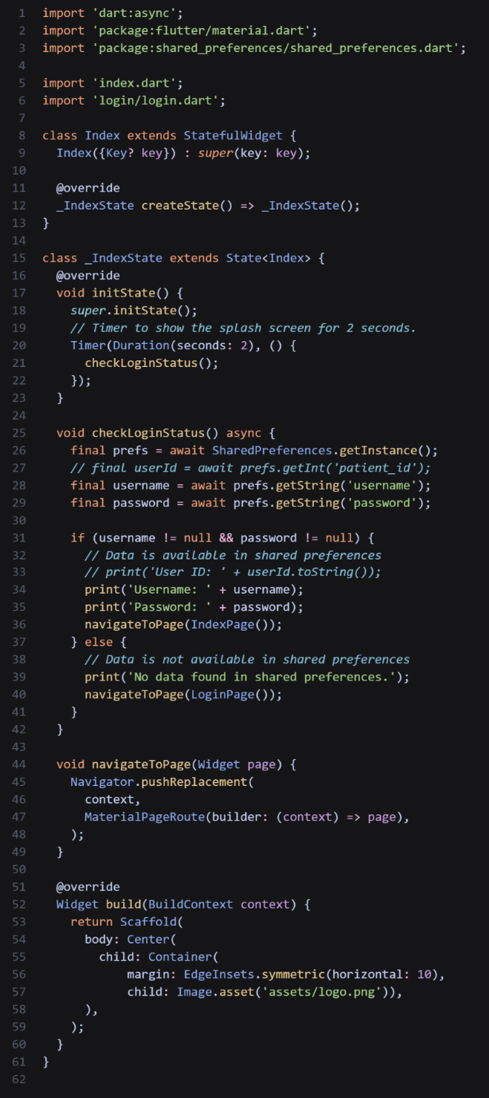

Figure 5.1.1 Splash Code in Flutter - Mobile App

## User Interface Development

In order to achieve the objective of developing a user-friendly and secure application, it was necessary to construct a user interface that enables users to access the application. To gain entry, users are required to possess a registered account and subsequently log in. Following this procedure, users will be granted access to the internal menus or pages of the application, as depicted in the illustrative diagram provided below.

[User account creation and login process.]

## Interface menu options

In order to make full use of the functionality of the application, the developers-built set of menus for the application so that the users can utilize the full set of features of the multi-interface app. For the web we used a sidebar as the main system of navigation, there are several links too that can be used to navigate around the website. For the mobile we used Flutter bottom navigation widget.

## The Process of Appointment

The appointment process in the Dental Clinic Management System (DCMS) is designed to streamline and facilitate the scheduling of appointments for patients. This process involves several steps, including requesting an appointment, availability confirmation, and finalizing the appointment details. The DCMS provides a user-friendly interface for both clinic staff and patients to manage and handle appointments efficiently.

## Handling Appointments from the Web

Handling appointments through the web interface in DCMS is a straightforward process that enables clinic staff to effectively manage the appointment system. Clinic staff can access the appointment management module through the web interface dashboard. From there, they can view and update appointment schedules, assign dentists or staff members to appointments, and send notifications to patients regarding appointment details or changes. The web interface provides a convenient and centralized platform for managing all aspects of the appointment process.

## Chapter Summary

In this chapter, we discussed the implementation process of the Dental Clinic Management System (DCMS). We explored the coding process, including the use of different technologies for the web and mobile interfaces. The user interface development was also highlighted, emphasizing the creation of user-friendly interfaces for both clinic staff and patients. Additionally, we covered the process of appointment handling, both in general and specifically through the web interface.

## Conclusion

In conclusion, the Dental Clinic Management System and its accompanying mobile app represent a transformative and comprehensive solution for enhancing the efficiency and effectiveness of dental practices. By seamlessly integrating booking functionalities into the mobile app, patients can effortlessly schedule appointments, reducing administrative burdens and increasing patient satisfaction.

Furthermore, the Dental Clinic Management System streamlines daily dental activities, providing dental professionals with a powerful tool to manage appointments, patient records, and treatment plans. The system's robust features ensure smoother workflows, improved patient care, and enhanced communication among the dental team.

By embracing this modern solution, dental clinics can position themselves at the forefront of technology and patient-centric care. The seamless coordination between the Dental Clinic Management System and the mobile app heralds a new era of efficiency, productivity, and patient satisfaction in the dental industry.

## Recommendations for Future Work

One avenue for future enhancement of the dental clinic management system and mobile app involves the refinement and expansion of the notification system. Currently, the app provides users with basic appointment reminders and updates. To further enhance patient engagement and communication, it is recommended that the notification system be extended to include real-time alerts for a broader range of interactions. These may encompass timely notifications for upcoming appointments, treatment plan updates, prescription reminders, and oral health tips tailored to individual patients. By incorporating these advanced notification features, the dental clinic management system and mobile app can create a more seamless and informative experience for patients, fostering increased patient engagement and satisfaction.

In order to provide a more comprehensive and streamlined patient experience, an important avenue for future development involves the integration of a dedicated medical files feature within the mobile app. This feature would empower patients to securely upload and store their relevant medical documents, dental history, treatment records, and any pertinent images directly within the app. Moreover, this integration could be extended to allow dental professionals access to these medical files during appointments, thereby facilitating more informed and personalized treatment decisions.

An area of substantial improvement for the dental clinic management system involves the implementation of a comprehensive inventory management module. Currently, the system effectively manages appointments, patient records, and treatment plans, but it lacks a dedicated feature to oversee the clinic's inventory of dental supplies and materials. To address this, it is recommended that a robust inventory management system be integrated, allowing clinic administrators to efficiently track, monitor, and manage the availability of dental equipment, instruments, and consumables.

The dental clinic management system has a good notification framework for communication and updates among personnel. However, the mobile app lacks a notification system, which can be enhanced in the future. Developing a comprehensive notification system in the mobile app can enable real-time alerts and updates for patients, including appointment reminders, treatment plan modifications, prescription alerts, and personalized oral health insights. Push notifications can also enhance the delivery of critical clinic announcements or time-sensitive updates.

**REFRENCES**

|  |  |
| --- | --- |
| [1] | A. A. F and M. J. F, Dental Clinic Management System, 2008. |
| [2] | ADA, "Glossary of Dental Clinical and Administrative Terms," 6 March 2016. [Online]. Available: https://www.ada.org/publications/cdt/glossary-of-dental-administrative-terms. [Accessed 2023 February 1]. |
| [3] | B. News, "Stone age man used dentist drill," BBC News, 6 April 2006. [Online]. Available: http://news.bbc.co.uk/2/hi/science/nature/4882968.stm. [Accessed 24 April 2023]. |
| [4] | D. (. Harper, " Etymology of dentistry," Online Etymology Dictionary, 17 May 2018. [Online]. Available: https://www.etymonline.com/word/dentistry. [Accessed 5 May 2023]. |
| [5] | Owen, K. Lorrie and ed, "Ohio Historic Places Dictionary," in *Dictionary of Ohio Historic Places*, vol. 2, St. Clair Shores, Somerset, 1999, pp. 1217-1218. |
| [6] | purdue.edu, Dentistry (DDS or DMD), West Lafayette: Purdue University, 2017. |
| [7] | T. Gunter and N. Terry, "The emergence of national electronic health record architectures in the United States and Australia: models, costs, and questions," *Journal of Medical Internet Research,* vol. 7, no. 1, p. e3, 14 March 2005. |
| [8] | C. P. Parag, A. R. James and H. S. Girish, "An empirical study of the Cobb-Douglas production function properties of software development effort," *Information and Software Technology,* vol. 50, no. 12, pp. 1181-1188, 2008. |
| [9] | I. Sommerville, "Iterative Development," in *Software Engineering*, Boston, Pearson, 2016, pp. 119-129. |
| [10] | A. U. D, "SELECTING A DEVELOPMENT APPROACH," 17 July 2014. [Online]. Available: https://www.acq.osd.mil/se/docs/Selecting\_a\_Development\_Approach.pdf. [Accessed 14 April 2023]. |
| [11] | U. D. o. Defense, MIL-STD-881C Work Breakdown Structures for Defense Materiel Items, U.S. Department of Defense, 2011. |
| [12] | I. (. o. E. a. E. Engineers), IEEE Std 830-1998 IEEE Recommended Practice for Software Requirements Specifications, Piscataway, NJ: IEEE (Institute of Electrical and Electronics Engineers), 1998. |
| [13] | Indeed Editorial Team, "What Is Problem Analysis? (With Processes and Useful Types)," Indeed, 25 November 2022. [Online]. Available: https://ca.indeed.com/career-advice/career-development/problem-analysis. [Accessed 15 April 2023]. |
| [14] | reqtest, "What Is Requirements Gathering?," ReqTest, 1 June 2020. [Online]. Available: https://reqtest.com/requirements-blog/what-is-requirements-gathering/. [Accessed 15 April 2023]. |
| [15] | H. Taherdoost, "International Journal of Academic Research in Management (IJARM)," *How to Conduct an Effective Interview; A Guide,* vol. 11, no. 1, p. 1, 2022. |
| [16] | K. Ankit, "OBSERVATION MEHTOD," *International Journal of Scientific Research,* vol. 13, no. 6, p. 1, 2022. |
| [17] | V. Claire, "What is Process Modeling? 6 Essential Questions Answered," bizagi, 15 December 2020. [Online]. Available: https://www.bizagi.com/en/blog/process-modeling-and-mapping/what-is-process-modeling-6-essential-questions-answered. [Accessed 15 April 2023]. |
| [18] | T. Nolle, "data flow diagram (DFD)," TECHTARGET, Octobar 2021. [Online]. Available: https://www.techtarget.com/searchdatamanagement/definition/data-flow-diagram-DFD. [Accessed 12 April 2023]. |
| [19] | B. Grady, R. James and J. Ivar, Unified Modeling Language User Guide, The, 2nd Edition, Michigan: Addison-Wesley, 2005. |
| [20] | Indeed Editorial Team, "Use Case Diagram: Definition and Examples," Indeed, 3 June 2022. [Online]. Available: https://www.indeed.com/career-advice/career-development/use-case-diagram. [Accessed 17 April 2023]. |

## APPENDICES

## APPENDEX A INTERVIEW QUESTIONS

|  |  |
| --- | --- |
| **1** | What is the process a customer goes through after coming to the establishment? |
| **2** | What kind of information do you collect from the customer before  administering them (e.g. medical history or recent history)? |
| **3** | What kind of services do you offer? |
| **4** | What kind of system are you currently using? |
| **5** | What are the problems facing you in current system? |
| **6** | If we could improve on your system, what will you want to see improved or added? |
| **7** | What is your payment system like? Do you use a merchant account? |
| **8** | What of your financial System? What expenses Do you usually have? |

## APPENDEX B Developing and implementing the application

­­

|  |  |  |  |  |  |  |  |
| --- | --- | --- | --- | --- | --- | --- | --- |
| **Tasks** | **November**  **2022** | **March 2023** | **April**  **2023** | **May**  **2023** | **June**  **2023** | **July**  **2023** | **August**  **2023** |
| Research proposal |  |  |  |  |  |  |  |
| Introduction |  |  |  |  |  |  |  |
| Literature review |  |  |  |  |  |  |  |
| Methodology |  |  |  |  |  |  |  |
| System Design |  |  |  |  |  |  |  |
| System Implementation |  |  |  |  |  |  |  |
| Conclusion |  |  |  |  |  |  |  |

­­­